Project requirements:

* 6.5 MVA, Single Phase transformer
* Operating Frequency: 500 Hz
* Input Voltage: 3 kV
* Output Voltage: 300kV
* Operating Temperature 110 °C

**Step 1 Selecting Core for 500hz application**

From JFE steel company website

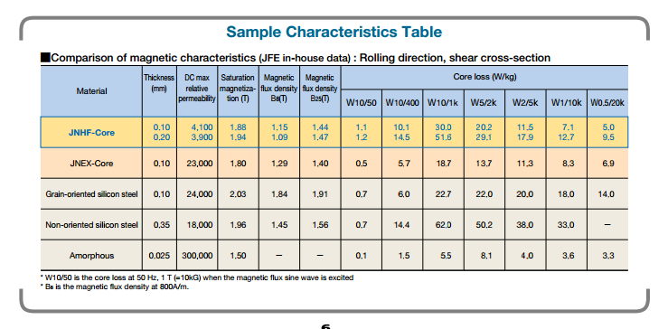

Lets assume operating Tesla vs loss stays linear until the saturation point .

There is no 500hz data readily available, so we need to curve fit the available data and determine and approximate loss value

Matlab code

x=[50,400,1000] %JNHF Core 0.1 mm at 1 Tesla

y=[1.1 , 10.1 , 30]

a=polyfit (x,y,2)

y=polyval(a,500)

x=[50,400,1000] %JNHF Core 0.2 mm at 1 Tesla

y=[1.2 , 14.5 , 51.6]

a=polyfit (x,y,2)

y=polyval(a,500)

x=[50,400,1000] %JNEX Core 0.1mm at 1 Tesla

y=[0.5 , 5.7 , 18.7]

a=polyfit (x,y,2)

y=polyval(a,500)

At 1 Tesla operating point

JNHF core 0.1 mm loss = 13.02 W/kg

JNHF core 0.2 mm loss =19.43 W/kg

JNEX core 0.1 mm loss = 7.5 W/kg

*stacking factor at 0,9 for 0.1 mm*

*stacking factor 0.92 for 0.2 mm*

**Insulation Calculation:**

Lv side is at 3 kV rms,

Hv side is at 300kV Rms

Oil impregnated Kraft paper breakdown voltage is around 40 kV/mm

Lets select our insulation thickness 8kV/mm for hV side

And 10 kV/mm for lv side.

Reasoning :

* The dielectric strenght of the oil impregnated paper is not linear , the thicker the insulation easier it will breakdown (electric field distribuition gets more nonlinear with the increased lenght).

*Higher the stress on the insulating material , shorter the lifetime.

*Altough the system is isolated from enviroment , oil will get impure by the time and its insulating capability will reduce.

* We should have at least 25 percent safety margin to pass the power frequency test , the insulation details are not given so 550 kV pf test is assumed.

550/300=1,84

40/1,84=21,74

Insulation will be thick , lets select use 0.6 constant

0.6*21,74=13

Put a safety margin of 30 percent

13*0,7=9,13.

Datasheet values will not be always met so lets assume 10 percent deviation

9,13*0,1=8,2=8kV/mm for hV side

For lV side insulation will be alot thinner so instead of 0.6 lets use 0.9

8*0.9/0.6= 12 kV/mm for lV side

Note: We are not operating with 50 hz but 500hz , so effective insulation will drop but we already had enough safety factor so this change will be ignored.

These values can be optimised with simulation results and real tests.

**Selecting Number of turns and operating tesla**

Our ratio is 1/100 ;

Lets select N1:10

N2:1000

Primary current is 6.5m/3k =2167 A

We are operating at 500hz , to have almost 100 percent skin depth our maximum cable diameter can be 5.8 mm according to table which is about awg#3 but we are operating at 110 C so we need to recalculate the skin depth correcting the resistivity, which will yield around 6.6 mm , still it is safe to remain at awg #3

\delta=\sqrt{{2\rho }\over{\omega\mu}}.

P=1,3*1,68*10^-8

W=2*3,14*500

M=1,257*10^-6

Result:3.326*10^-3

Instead of using enmayed wire , it is better to use copper stripes and insulate with oil impegrated Kraft paper

Current density of primary: 3,5 A/mm^2

Primary current :2200 A

Required Area : 625 mm^2

Allowed Thickness : 6.6 mm

In Between insulation

Lets use 25x5 mm copper stripes with 0,2 mm insulation in between and cover the whole with 0.5 mm paper.

Our total dimensions will be around 27x27 .

Primary turns 10,

Core Leg 1 is 27mm*10 = 270 mm,

Current density of Secondary: 3,5 A/mm^2

Primary current :220 A

Required Area : 62,5 mm^2

Allowed Thickness : 6.6 mm

In Between insulation

Lets use 10x6.5 mm copper stripe

Vout is 300 kV,

Nturns:1000

Voltage drop per turn : 300 V

Lets cover the copper with 0.2 mm insulation.

Thickness of the stripe is almost 7mm

Lets wound 40 turns per layer,

40*7=280mm for leg 2

Voltage drop per 40 turn =40*0,3=12 kV

12/8=1,5 mm insulation is required per layer (including the core )

For 40 turns per layer we require 1000/40 =25 layers

Layer thickness= 10.4+1.5= 12 mm

12*25=300mm (secondary winding thickness)

**Core Dimensions**

*For 10 turns 3000V and 1 Tesla , 500 hz required Core area is 0,136 m^2*

Lets use a square core area of 370mm*370mm

Selected core JNEX core 0.1 mm loss = 7.5 W/kg stacking factor 0.9

Real Area of the core 410*410

Height of the core : 1120mm

Length of the core : 1220 mm

Inner spacing : 400mm to 300 mm

**Core Losses:**

**Copper Losses:**

**Optimization:**